Teton Canyon Forum #4 12/12/13
During the presentation:
Prescribed Fire Options:
1b:
Will you use mechanized equipment to put in fireline? No, it will be put in by hand and natural features will be utilized.
Will the grazing permittee be excluded from the allotment for burning? Are there concessions for them? They won’t be able to use the burned area for 2 years after the burn. The Range Con will work with the permittee to come to a compromise, be it a move onto a vacant lot or possibly working with the Teton Regional Land Trust to find another area to graze during that time. The burn units would be implemented so that they will only be impacted on part of the allotment at a time.
2:
When was the last Lynx sighting in this area? None, and it’s not “critical” habitat. There was a sighting in the 90’s in near Cold Springs.
3:
Are there any domestic sheep grazing allotments in this area? No, not anymore.
Mechanical Treatment Options:
4a:
Why don’t you chip the cut material instead of burning piles? Then there won’t be smoke. It’s an option. We have to be careful how much material is being put on the ground, it can impact the vegetative response. Also need to identify funding sources, chipping is expensive.
4a/b:
Could these areas be used for firewood? Yes, at the campground there would be an access concern, but at the Alta Water Source site it would be ok.
4d:
What status is the Teton habitat for bighorn sheep? It’s a small population, 100-125. They used to migrate into lower elevations for winter, but we are no longer seeing that migration and they winter at high elevation. Wyoming Game and Fish are trying to expand winter habitat
Do bighorn sheep invite predators that aren’t already there? No, mountain lions are their biggest predator, but the mountain lions rely more on mule deer for food. If the mule deer are there, then the mountain lions are already there, but the sheep haven’t been drawing in the mountain lions on their own.

Timber Harvest/Logging Options:
4e:
Is there any long term planning for more pockets of timber harvest in the future? We are limited by the National Environmental Protection Act (NEPA) process for how long out we can plan projects. We are trying to present the options to the public, however there may be opportunity for other options in the future.
4f :
Do you have an estimate of board feet in those harvest areas? It will be low, few hundred thousand.
Is this economically viable for logger? Yes, because they are taking the whole area not selective thinning. The Boy Scouts have used loggers to get out hazard trees. This would not be for the big production mills, but the smaller mills out there.
Are they using existing roads? Yes, 4e is at the end of Teton Canyon road, 4f would utilize the Boy Scout camp roads as well as an existing road which accesses a water diversion/ditch.
How far is that from the creek, would you build sediment catchments? It’s about 100 yds. With the small areas of the cutting (each about an acre) and level terrain, there would not be not much overflow sediment, optimal time period for cutting (later fall) would minimize impacts like compaction as the following freeze thaw cycle will help the soil, and by cutting late in the season precipitation is more likely to occur as snowfall and the following spring will have a flush of new growth to further stabilize soils. Small group harvesting optimizes regeneration, if it doesn’t regenerate, then we can go in and plant. This would introduce a new age class for future resiliency (against disease and insect infestations) that naturally occurs from things like fires, avalanches and wind events.
Age class variance is a good reason for long term planning.
Is the long term planning more of a budget issue? No under the environmental process, clearances need to be obtained, and they only last for certain periods of time
Is someone doing the long term planning, you just can’t commit to the plan? Yes
Roadless Area
Aren’t there already roads there? Yes. There are/were old roads there. One of the purposes of the Roadless Act was to identify and set aside areas that had a very low or non-existent road density, or where the existing roads were not “classified” roads that were maintained for public use. Other ecosystem functions such as watershed or wildlife habitat integrity are deemed to be the most important management for these areas. Basically the roads are abandoned to be reclaimed by nature.
By using the existing roads, you can return the resiliency of the forest. The Roadless Act enacted by Congress and Presidents looked at maps to designate areas. There is a process to get a timber harvest done in a roadless area, but it must start with a huge amount of public support.
But you could potentially do mechanical treatment without a road? Yes. Only logging would require building or improvement of roads. Other mechanical treatment options exist: mastication or hand crews with chainsaws. These treatments would not require any road building, and also do not require review from a higher level. They are specifically mentioned in the Act as acceptable management activities.
4g:
When was the previous logging that those roads came from? The data on that was lost in the Rexburg flood. Most recently it was probably back in the 60’s. Dave Green said his teacher logged in the early 1960’s.
There’s a cost factor to the handcrews, doesn’t logging take care of some of the cost? Yes, but you have to improve roads, and they would need to be rehabilitated when it was finished. So in the end the Forest Service would still likely end up paying for some of the work.
How far can you use a harvester forwarder? The area is too small. Forwarders are not common in this area and it is highly unlikely that a logger working on this project would have one. The Forest Service could require its use, but that would increase the cost. Given the small size of the material that would be removed, the relatively small area to be treated and associated complexities the Forest Service would likely need to subsidize the treatment of this area.
The more we can limit the burning the better for health reasons. The oldest residents in Alta are in the mouth of the canyon and get the bulk of the smoke. Whatever we can do to reduce fire is better. A lot of mastication can put too much fuel on the ground, increasing wildfire danger.
Clicker Voting
There have been no actual costs presented; it’s hard to vote without cost component. For the wildlife habitat component, there are good sources of money for parts or all of those treatments from NGO’s. For fuel reduction, the cost of the reduction is less than a wildfire. Projects like these are part of what we are already tasked with within our current budgets, this would put some of that workload in Teton Canyon.

Teton Canyon TAAF Forum  December 12, 2013  Teton High School, Driggs, Idaho | Evaluating Options  5 = I fully support this option  4 = I like it, good enough  3= I have mixed feelings about this option  2=I prefer something different  1= I just don’t like it
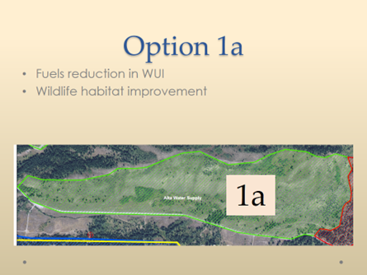 | 1 response = 3  4 response = 4  5 response = 5
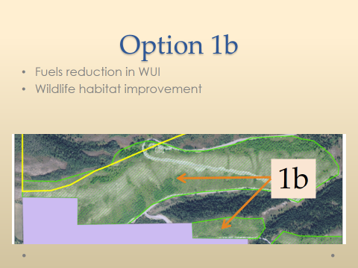 | 2 response = 3  - Irrigation diversion in area, concern about sediment  - Prefer prescribed burn over something else, but would prefer nothing over all options.  4 response = 4  5 response = 6
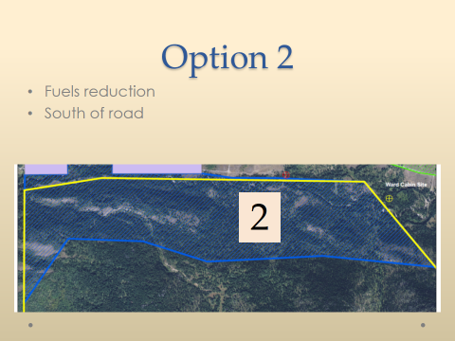 | 1 response = 1  - I don’t think you should be burning in steep areas. Leave roadless area alone, without natural barriers (to south) may wind up burning more  2 response = 0  3 response = 8  -mixed feelings, ok to burn, concern about the smoke, mostly concerned about wildlife area, it needs to be improved, don’t care how you do it  -would like to see tools used that will meet the objectives, if a mosaic can be provided, that will enhance entire ecosystem. something needs to be done, don’t care what the prescription, the end results need to be achieved with the appropriate tools to achieve age class and species diversification of forest  4 response = 2  5 response = 1
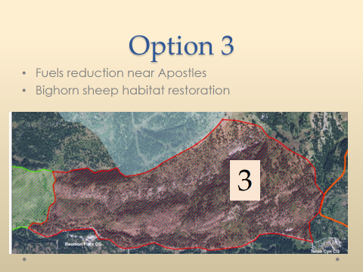 | 1 response = 0  2 response = 2  I support the objective. FS needs discretion to use the tools they need to accomplish what needs to be accomplished in the canyon to make this area critical wildlife habitat (recommend expanding this polygon to the east)  3 response = 1  4 response = 5  5 response = 5
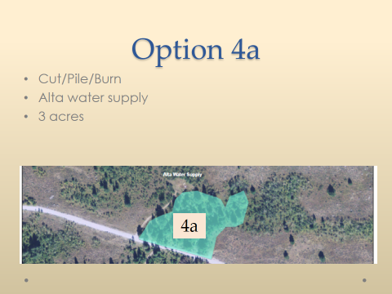 | 1 response = 0  2 response = 1  Firewood opportunities need to be considered here (firewood or chipping)  Prevent trails from occurring and or have money appropriated to repair tire scars  3 response = 2  4 response = 5  5 response = 6
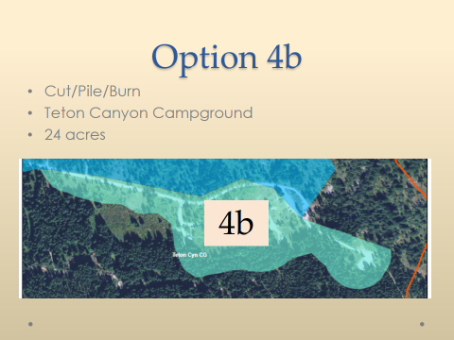 | Response 1 = 0  Response 2 = 1  Response 3 = 1  Response 4 = 7  Response 5 = 5
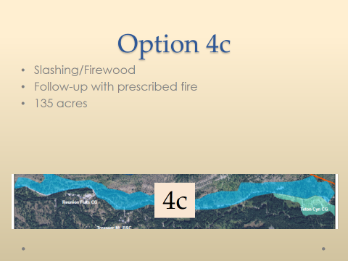 | Response 1 = 2  Prefer prescribed burning to mechanical treatment. More concerned about people driving off road and creating roads.  Response 2= 0  Response 3 = 0  Response 4 = 6  Response 5 = 5
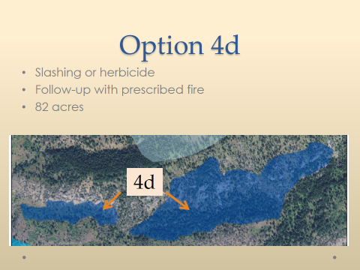 | Response 1 = 1  If you’re going to treat, would rather see burn than chemicals used. May be strings attached to using outside money for the chemical purchase.  Response 2 = 1  Treatment isn’t necessary if the information to treat is being based on 1800 polls. Since there was only 1 ewe, it does not justify doing anything.  Response 3 = 1  Response 4 = 3  Response 5 = 3
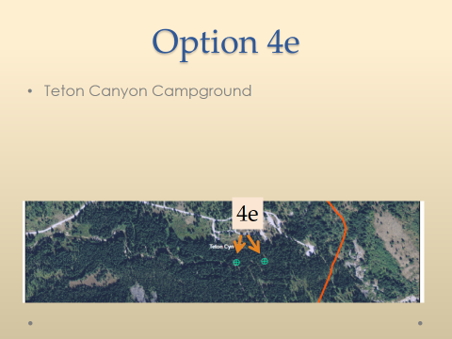 | Response 1 = 0  Response 2 = 0  Response 3 = 2  -What is definition of “old growth”?  -Spruce won’t be useable because of twisted grain, if no one wants it what will you do with it?  Response 4 = 4  Response 5 = 6
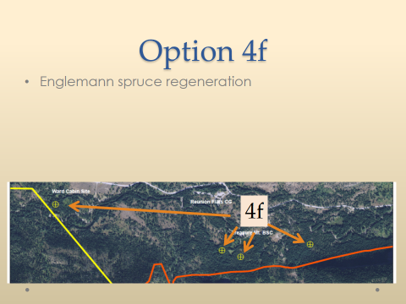 | Response 1 = 0  Response 2 = 1  Stay farther away than 100 yards from creek.  Response 3 = 0  Response 4 = 2  Response 5 = 9
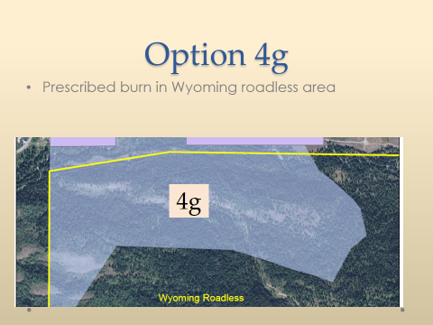 | Response 1 = 1  Bad combination  Response 2 = 4  Prefer mechanical to prescribed burn  Response 3 = 1  Voted 3, something needs to be done, whatever managers think can work----do  Response 4 = 1  Response 5 = 6  Logging is best choice (use the resource)
 | “Get into the document the desire for staging the treatments in the canyon for the long term health of the forest”

Next meeting in January will addressing camp sites.

