April 6, 2017

ADS 3000 Excel Workbook Version 4.10.2017 – Update Procedure

Originally published in 2009 for Windows XP and Vista, this update procedure has been revised so that the ADS Excel Control Panel can be used with Microsoft Office Excel versions through 2016 running under Windows 10. The primary change in this procedure is that the installation and registration of the necessary files should be performed in the c:\Windows\SysWOW64 directory.

Microsoft has issued security updates to previous versions of Windows that disable many Microsoft Active X controls by setting a “kill bit” in the Windows registry. Any program that relies on these controls will see an error message when it attempts to access the disabled control.

The ADS 3000 Excel workbook is one of the affected programs. If one of these Microsoft updates is installed, the ADS 3000 Excel workbook is no longer able to open the COM port to transfer data.

The technical details for why Microsoft issued these updates are described on the Microsoft Developer’s support website. While this website explains the reasons for disabling the controls as well as a recovery process, the description is quite technical and doesn’t include all the detail needed to fix ADS 3000 Excel interface. However, if you are interested in this background the web page can be viewed at,

http://blogs.msdn.com/vsod/archive/2009/06/05/visual-basic-6-controls-stop-working-after-security-advisory-960715.aspx

The purpose of this ADS procedure is to guide you through a step by step process to install the new Microsoft Active X controls and restore full ADS 3000 functionality. Four steps are required:

- Save a new version of the ADS 3000 Excel Workbook to your ADS 3000 folder
- Do a search to find and delete all files with an “.exd” extension
- Install and register four new Active X control files from Microsoft
- Start the ADS 3000 Excel workbook, ADS_3000_Version_4.10.2017.xlsm

The following pages of this document expand on these four steps and provide screen shots to help guide you through the process. If you have any questions about this update or need additional explanation do not hesitate to call us (208-520-9192) or send an email with your questions.

Note: If you have not experienced this problem in using your ADS software it may be that your system does not have the latest Windows updates installed.
ADS 3000, Version 4.10.2017 Update Procedure

This procedure requires 9 files that can be downloaded from the Wilderness Systems and Technologies website, http://www.wildernesstechnologies.com/v4.html
While each file can be downloaded individually you can also download the zip folder, “ADS_v4.10.2017.zip” and get all the files at once after unzipping on your PC.

ADS_3000_Version_4.10.2017.xlsm 99 KB 4/08/2017
comct232.inf 1 KB 3/24/2009
comct232.ocx 167 KB 3/24/2009
mscomct2.inf 1 KB 3/24/2009
mscomct2.ocx 644 KB 3/24/2009
mscomctl.inf 1 KB 3/24/2009
mscomctl.ocx 1,045 KB 3/24/2009
mscomm32.inf 1 KB 3/24/2009
mscomm32.ocx 117 KB 3/24/2009

- Download the Zip folder “ADS_v4.10.2017.zip” to your desktop or other convenient location and extract the files.

- In the Unzipped folder copy the “ADS_3000_Version_4.10.2017.xlsm” file to your ADS programs folder or the location you use to run the ADS software

- Do a search to find all files on your c: drive with an “*.exd” extension - In Windows 10 one way to do the search is to open a File Explorer window (see below), select the Advanced options -> System files checkbox, highlight the C:Drive and enter “*.exd” in the search box. All files with an .exd extension will be listed in the search results and can then be deleted. These files will be regenerated the next time the parent program is started.

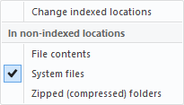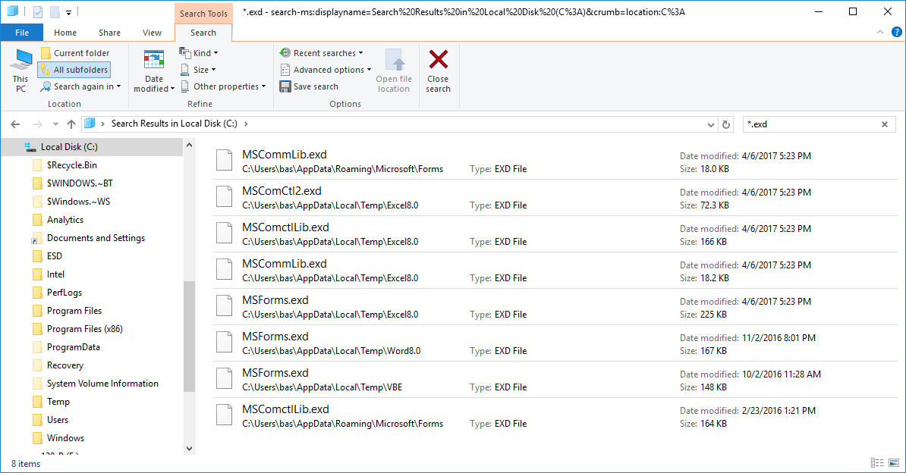

- Install and register four updated Active X control files from Microsoft

Copy the eight files with .inf and .ocx extensions from the Unzipped folder
to the C:\Windows\SysWOW64\ directory.

Now right-click on one of the .inf files, and choose 'Install' with a left-click (this should take a matter of a couple of seconds and there will be no confirmation message).

Next you will register the .ocx file that has the same filename as the .inf file you just installed by opening an Administrative Command Prompt window (see below) which you access by right clicking the Windows 10 flag on the task bar. Once the window is open change to the SysWOW64 directory by typing (without the quotes):

“cd WINDOWS\SysWOW64\

After the directory is changed you can type:

“regsvr32 <filename>.ocx'”

where <filename> is replaced by the name of the .inf file that was just installed. For example if you installed the comct232.inf file, the run command would use the comct232.ocx file and the Command Prompt window would look like this:

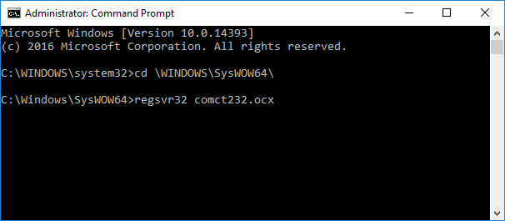

Repeat these two steps for the remaining pairs of files.
Restart the ADS 3000 Excel interface program. The ADS Excel worksheet will now show version 4.10.2017 and will look similar to this,

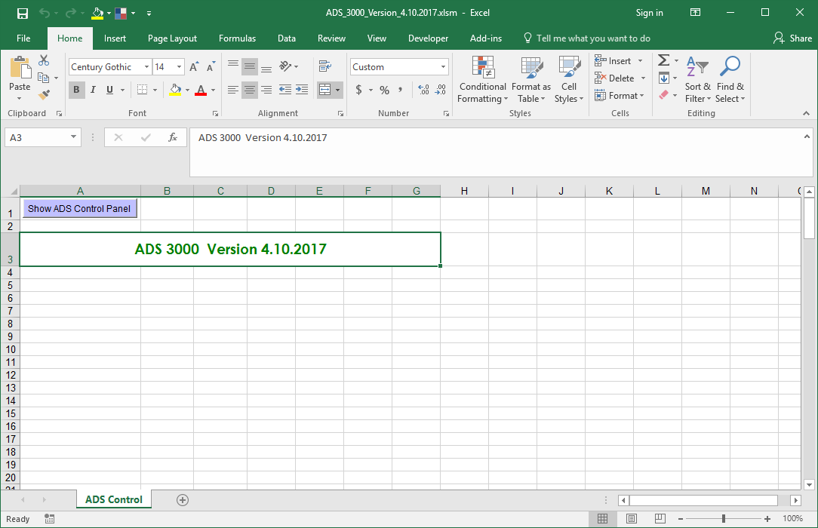

Now when you click on the “Show ADS Control Panel” button things should start up normally. Depending on which COM port you use you may have to re-enter the appropriate COM port number on the “Advanced Functions” page. The default port number is 1, but your system may use a different number if you are using a USB to serial converter for the ADS communication cable or if you have other hardware using COM ports.

After completing this update you can delete the Zip folders or keep them as a backup in case this update needs to be performed on a different PC.

Do not hesitate to call or email if you have questions. We would be happy to help.

